**Angeles  City Science High School**

**Science 9**

**Name:** Paul Gerald D. Pare **Section:** 9 - Adenine

# C:\Users\DEPED\Desktop\ADM specs\ADM cover and icons\ADM Icons\Balikan.jpg

# *What’s In*

**Directions**: Label the diagram of an erupting volcano with its parts and materials. Refer to the definition of terms on the table below. Write your answers in your notebook/on a separate sheet of paper.

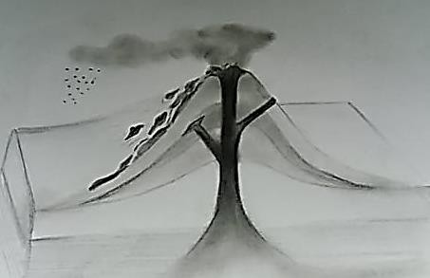

1. Ash
2. .
3. Crater

|  |  |
| --- | --- |
| ash | Consists of fragments of rocks, minerals, and volcanic  glass created during volcanic eruptions |
| crater | A funnel-shaped opening at the top of a volcano |
| magma | Molten rocks beneath the volcano |
| lava | Magma that flows out of the earth’s surface |
| main vent | Tunnel-like inside a volcano where magma travels to reach  the earth’s surface |

1. Main Vent
2. Lava

5. Magma

Figure 1. Erupting volcano

# C:\Users\DEPED\Desktop\ADM specs\ADM cover and icons\ADM Icons\Tuklasin.jpg

# *What’s New*

## Activity 1. Volcanoes in the Philippines Objective:

1. Classify volcanoes as active or inactive.
2. Plot the locations of active and inactive volcanoes in a map using latitude and longitude.
3. Differentiate active from inactive volcano.

**Materials:** Philippine map, colored pen, triangular rules

## Procedure:

* 1. Using a Philippine map, plot the locations of the given volcanoes on the table below. Assign colors for each volcano and indicate this on your legend.
  2. Answer the guide questions given and write it in your notebook/on a separate sheet of paper.

|  |  |  |  |  |
| --- | --- | --- | --- | --- |
| **Volcano** | **Latitude** | **Longitude** | **Number of Historical**  **Eruptions** | **Latest eruption of activity** |
| Arayat | 15.210 | 120.740 | - | - |
| Cabaluyan | 15.690 | 120.330 | 0 | - |
| Cocoro | 10.880 | 121.20 | 0 | - |
| Iraya | 20.470 | 122.010 | 1 | 1454 |
| Kanlaon | 10.410 | 123.130 | 26 | June 3, 2006 |
| Mayon | 13.260 | 123.690 | 52 | January 13, 2018 |
| Pinatubo | 15.140 | 120.480 | 2 | July 19 - August 16, 1992 |
| Pudung | 7.920 | 124.630 | 0 | - |
| Smith | 19.540 | 121.910 | 5 | 1924 |
| Taal | 14.010 | 120.990 | 34 | January 12, 2020 |

**Legend:**

|  |  |
| --- | --- |
|  | volcano that has no record of eruption |
|  | volcano that has erupted 1 to 5 times |
|  | volcano that has erupted 6 to 10 times |
|  | volcano that has erupted more than 10 times |

## Guide Questions:

Q1. Are all the volcanoes found in the same location? No

Q2. Which of the volcanoes has the greatest number of eruptions? Least number of eruptions? No record of eruption? Mayon (Greatest), Iraya (Least), Arayat, Cabaluyan, Cocoro, Pudung(No Record)

Q3. How will you classify volcanoes with records of eruptions? Active Volcano are volcanoes that have record of eruption within the last 10,000 years.

Q4. How will you classify volcanoes with no record of eruption? Inactive Volcanoes are those that have no record of eruption.

Q5. In your own words, differentiate an active volcano from an inactive one.Active Volcanoes are those that have record of eruption while inactive has no record of eruption.

